Surgical AI Models & Datasets
Surgical AI Models & Datasets

Goal:
Analyze Models and Datasets mentioned in the paper, and highlight key differences and similarities across the research. After finding unique traits in each one, we will decide what and what not to integrate into our own model. Finally, we will benchmark these models ourselves, and see how they perform.

A. Basic Models
General AI systems we build on or measure against.
Model / paper | Distinct or repeated across the field? | What we'd build into our model
CLIP  arXiv 2103.00020  2021 | REPEATED created a baseline AI model that matches pictures to works, allowing other models to build off of. | Use this matching approach as our foundation, so we have to do labeling by ourselves.
GPT-4o  openai.com/gpt-4o  2024 | REPEATED A generic LLM that is can be used as a baseline | Use only as a baseline to beat. It can spot certain objects, but unable to perform in surgical environments
Gemini  deepmind.google  2024–25 | REPEATED The other common off-the-shelf baseline. | Second baseline for comparison.
CONCH  arXiv 2307.00184  Nature Medicine 2024 | DISTINCT Trained on medical data to be better than other generic AI models. | Take the lesson, not the model. Shows that using medical specific datasets can result in better results, compared to generic AI models.

B. Surgery video collections (datasets)
The labeled video we can train and test on.
Dataset / paper | What it offers | How we'd use it | Labels
Cholec80  IEEE TMI 2016  EndoNet | 80 gallbladder-removal videos labeled with 7 steps and 7 tools. The field's standard yardstick. | Our main benchmark. Everyone reports on it, so it makes our results comparable. | - Annotation Type: Phase labels (temporal segmentation) + tool presence (multi-label binary)  - 7 phases (frame-level, one per frame): Preparation, CalotTriangleDissection, ClippingCutting, GallbladderDissection, GallbladderRetraction, CleaningCoagulation, GallbladderPackaging.  - 7 tools (binary presence, tool counts as "present" if ≥half the tip is visible): Grasper, Bipolar, Hook, Scissors, Clipper, Irrigator, SpecimenBag.  - No bounding boxes, no pixel segmentation.
CholecT50  arXiv 2109.03223  Rendezvous | 50 videos labeled with action phrases like “grasper – retract – gallbladder.” | 1Use later to test action reading, once basic step/tool scores are solid. | - Action triplet labels + phase labels + sparse bounding boxes .  - Frame-level multi-label triplets in the form <instrument, verb, target>.  - 6 instrument classes, 10 verb classes, 15 target classes, 100 valid triplet classes (not all 900 combinations occur).  - Same 7-phase labels as Cholec80 (since 45 of the 50 videos come from Cholec80).  - Instrument-tip bounding boxes provided for only 5 of the 50 videos, with box-to-triplet matching labels for those.
CholecTriplet 2021  arXiv 2204.04746  challenge | A public competition that set shared scoring rules for action reading. | Adopt its scoring and data splits so our action numbers line up with others. | - Not a new label set, it's a standardized evaluation protocol on top of CholecT50  - Adopts CholecT50's triplet taxonomy and fixes the train/test video splits so results are comparable across submissions.  - Scoring is via mean Average Precision (mAP) on triplet recognition, computed at the instrument, verb, target, and full-triplet level.  - Classification task.  - No Bounding Boxes  - Annotation Type: frame-level multi-label triplet classification, no localization.  - However there is a CT 2022 which does have bounding boxes but they are weakly supervised.
AutoLaparo  arXiv 2208.02049  MICCAI 2022 | 21 videos of a different operation (hysterectomy), labeled for step, tool, and action. | Our generalization check , does the model still work on an operation it wasn't trained on? | - Three separate annotation sets for three tasks.  - Phase: 7 phases, frame-level, all 21 full videos: Preparation, Dividing Ligament and Peritoneum, Dividing Uterine Vessels and Ligament, Transecting the Vagina, Specimen Removal, Suturing, Washing.  - (Laparoscope motion: 7 classes (Static, Up, Down, Left, Right, Zoom-in, Zoom-out) on 300 hand-picked 10-second clips.  - Pixel-wise semantic segmentation: 1 anatomy class (Uterus) + 4 instrument classes, each split into manipulator/shaft parts  - Grasping forceps, LigaSure, Dissecting and grasping forceps, Electric hook.  - giving 9 foreground classes total, annotated on 6 sampled frames per clip (1,800 frames).
SurgToolLoc  arXiv 2305.07152  Intuitive | Large robot-surgery set for finding where tools are on screen. | Only if we target robotic surgery. | - Two separate sub-challenges, both over the same 14 tool classes.  - Classification: frame-level multi-label tool presence (no location).  - Detection: 2D axis-aligned bounding boxes per tool per frame.  - 14 tool classes: needle_driver, monopolar_curved_scissor, force_bipolar, clip_applier, tip_up_fenestrated_grasper, cadiere_forceps, bipolar_forceps, vessel_sealer, suction_irrigator, bipolar_dissector, prograsp_forceps, stapler, permanent_cautery_hook_spatula, grasping_retractor.

C. Models that learn by matching video to words
These learn from clips that already come with a text description (often lecture narration), so they need little hand-labeling. These models are what we want most to borrow from.
Model / paper | Distinct or repeated across the field? | What we'd build into our model
SurgVLP  arXiv 2307.15220  2023–25 | DISTINCT gets training text by auto-transcribing spoken narration in teaching videos | Mine narrated surgical videos for training text instead of paying for it.
HecVL  arXiv 2405.10075  MICCAI 2024 | REPEATED Learning at several levels at once , moment, step, whole operation , recurs in the strongest models. | Train at multiple time scales so the model grasps how steps fit together, not just single frames.
PeskaVLP  arXiv 2410.00263  NeurIPS 2024 | REPEATED Cleaning up noisy transcripts and teaching the usual order of steps also happens. | Run captions through an LLM to clean them, and add a step-order signal during training.
SurgLaVi / SurgCLIP  arXiv 2509.10555  2025–26 | REPEATED Big, hierarchically-organized data. gives the largest, most consistent gains. | Organize our training data by hierarchy and reuse their open 113k-pair subset to bootstrap.

D. Models that can talk about surgery
Model / paper | What it is. | Distinct or repeated across the field? | What we'd build into our model | Code | Weights/Parameters
GP-VLS  arXiv 2407.19305  2024 | - A general-purpose vision-language model for surgery.  - Instead of training a model to just classify surgical phase or tool, they combine general medical knowledge with surgical visual understanding in one model, so it can be asked open-ended questions rather than pick from a fixed label set.  - Training data 3 categories:  - Medical knowledge (reused, not new): MedMCQA, MedQA, Medical Flashcards, MedInstruct52k, standard public instruction-tuning sets for general medical knowledge.  - Surgical knowledge (new): two new QA datasets they built, SurgTextBook-QA and MedMCQA-Surgery.  - Surgical vision-language (new): five new training sets built on top of four existing surgical datasets, covering action recognition, phase recognition, tool-action triplet recognition, tool localization, and advanced surgical scene QA.  - Their benchmark is SurgiQual, a new evaluation suite they propose specifically, because there was no existing way to evaluate a general-purpose VLM. | Mixes medical “book knowledge” (exam questions) with looking at surgery images. | Add medical-exam Q&A to our training mix so the model has background knowledge, not just vision.  GP-VLS is best framed as a paper-only contribution. A good illustration of the general-knowledge-plus-vision idea, but not something you could actually build on or reproduce today. | N/a | n/a
SurgVLM  arXiv 2506.02555  2025q | - SurgVLM is a unified vision-language model designed for surgical intelligence.  - It supports diverse surgical tasks within a single modeling pipeline, spanning visual perception, temporal analysis, and high-level reasoning.  - Includes…  - SurgVLM-DB: a surgical multimodal corpus for training surgical vision-language models. Built by merging 23 existing public surgical datasets. 1.81M frames, 7.79M conversations, spanning 16+ surgical types and 18 anatomical structures.  - SurgVLM Models: two specialized variants for instruction following and reasoning  - SurgVLM-Bench: A Comprehensive Surgical Benchmarks for VLMs  - 10 surgical tasks organized hierarchically from low-level perception to high-level reasoning: Instrument Recognition, Instrument Localization, Tissue Recognition, Tissue Localization, Phase Recognition, Step Recognition, Action Recognition, Triplet Recognition, Critical View of Safety (CVS), and multi-task VQA. | Training on a huge set of question-answer conversations, and bringing a built-in test, is becoming the standard. Also is a huge dataset-unification which is relevant to the lit review. | Build an instruction-style Q&A training set, and ship our own built-in benchmark alongside the model. However as of now you can’t download the model, run their code, and can only access a small part of their data. | https://jinlab-imvr.github.io/SurgVLM/  https://github.com/jinlab-imvr/SurgVLM | N/A
Chatbot-style surgical models, useful if we want the model to explain itself or help write notes.
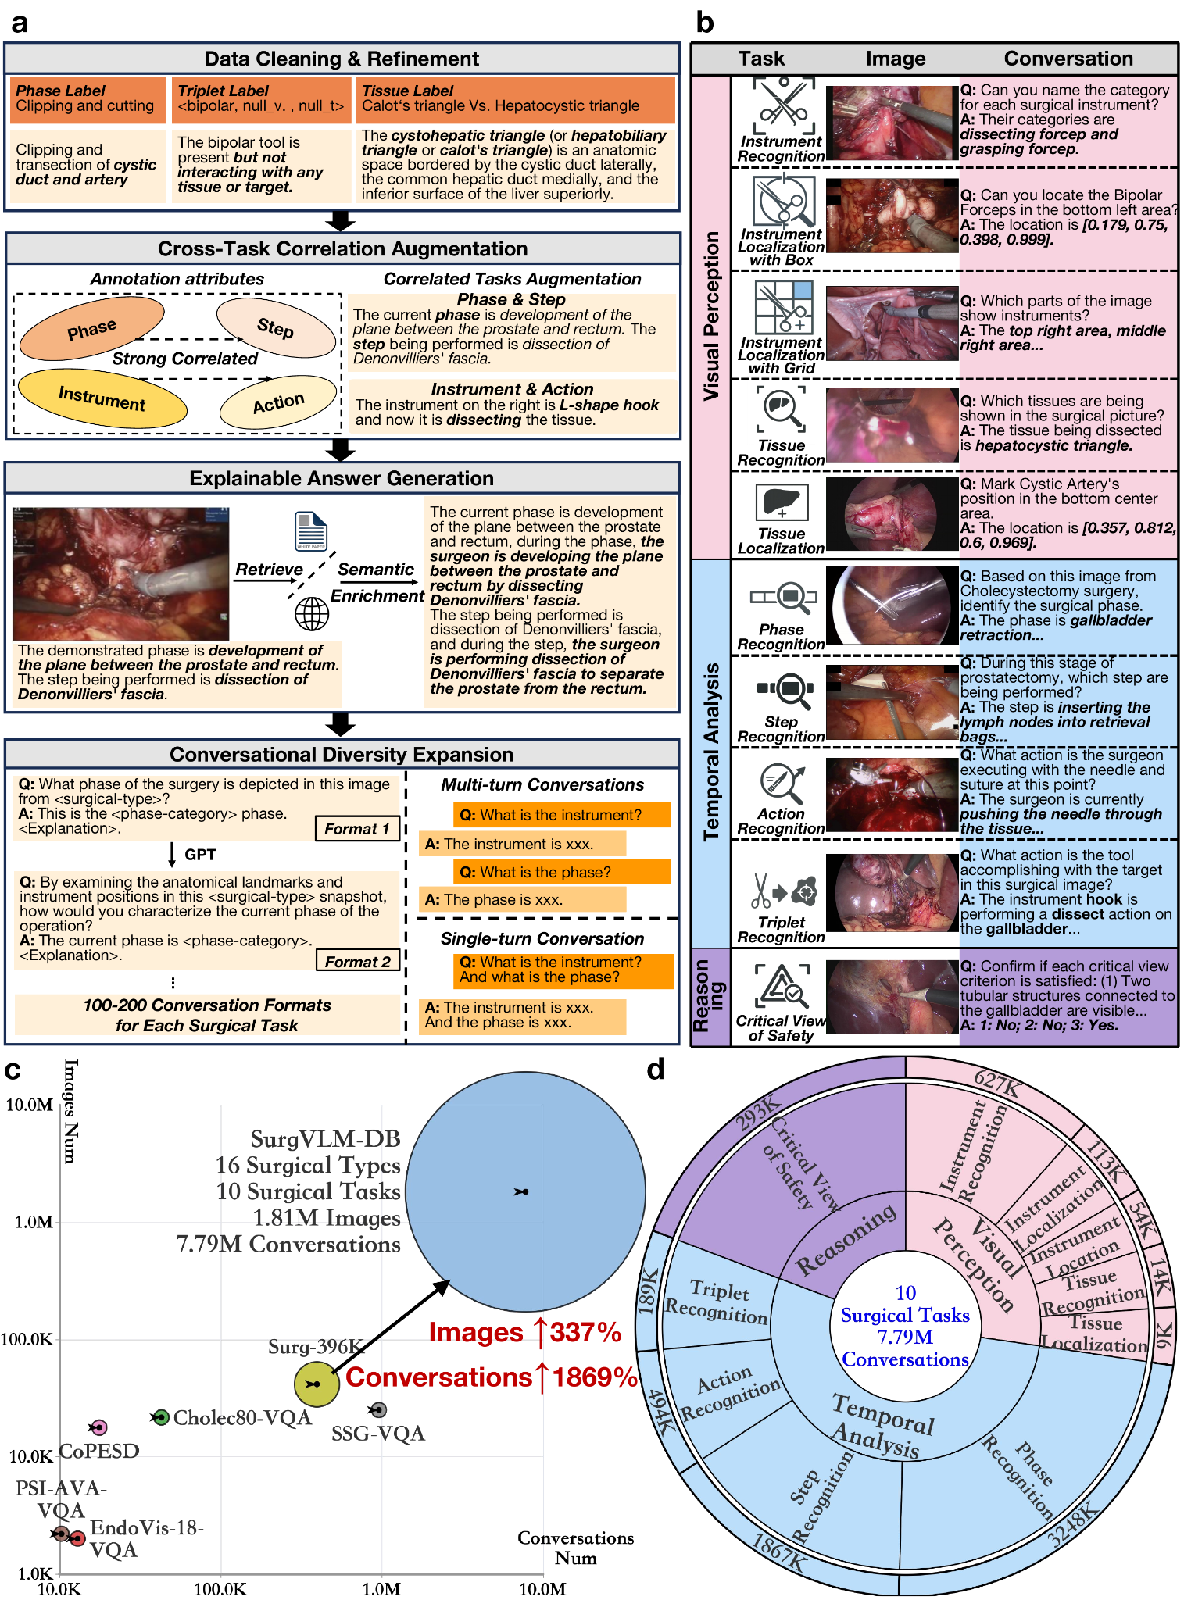

New models and datasets
Models
Endo-FM (arXiv 2306.16741) Foundation model, trained off large endoscoping video data. Used for in-depth endoscopic video analysis
- Can be used to pretrain a video backbone on unlabeled endoscopy images. Allows the model to learn basic surgical motions before further fine-tuning of the model. We could use it as our starting video backbone and fine-tune it on our labeled tasks, so we need far fewer hand-labels to get good accuracy.
GSViT (arXiv 2403.05949) : A general-surgery video model trained on 680 hours of surgery footage across 28 procedures, designed to be fast and efficient.
- It can be used as a lightweight foundation to benchmark against one of our bigger, better models. Just to be used as a baseline
SurgeNetXL (arXiv 2501.09436) : A large self-supervised surgical model showing that simply using more training video keeps improving results.
- This highlights the importance of large pretraining datasets for the models. Shows that we need a very large sample size of surgical video for pretraining in order to get better performance from the model
VidLPRO (arXiv 2409.04732) : Learns from short video clips paired with text (not single frames), and is strong at naming the operation's current step without extra training.
- Leverage a video-based design rather than single frames so that our model can better capture motion and timing.
Surgical-VQA (arXiv 2206.11053) : The first model to answer written questions about a surgery image (e.g., which tool is being used).
- Use the question-answer framework of this model to train our model to use contextual understanding and prior surgical training to answer surgery-related questions and further build its understanding.
Surgical-VQLA (arXiv 2305.11692) : Like Surgical-VQA, but it also points to where in the image the answer is, making it more trustworthy.
- We can integrate this by using the feature of pointing out where the answer is in the image to create more trustworthy and checkable answers, which is important in the surgical scene.
SurgicalGPT (arXiv 2304.09974) : Adds a GPT-style language part to a surgical model so answers read as natural sentences.
- We could use this framework of a language model that creates text output, allowing for elaboration of answers and possibly a surgical notetaker (help draft notes)
SSG-VQA-Net (arXiv 2312.10251) : Answers questions using a “scene graph” of structured facts about which tool is acting on which body part, not just raw pixels.
- The SSG-VQA dataset uses a semantic scene graph as a suitable representation to generate diverse question-answer pairs. A semantic scene-graph representation provides scene knowledge by detecting objects and their attributes and connecting relationships and interactions between objects in the scene. Using this info, we could feed our model the same kind of structured scene data in order to create more reliable and accurate reasoning.
LLaVA-Surg (arXiv 2408.07981) : A surgical chat assistant trained on 102,000 question-answer pairs built from teaching videos.
- We could use this same form of training, as this model has exceptional skills in answering open-ended questions. Using this will allow our model to outperform other general models.
EndoChat (arXiv 2501.11347) : A chat model for endoscopy that ties each answer to specific regions of the image.
- This model shows that we should ground our answers to surgical images, allowing them to be more accurate and checkable.
- This can also mitigate hallucinations from the model.
SurgVidLM (arXiv 2506.17873) : Understands both the whole video and fine close-up detail at the same time.
- We can utilize this same dual strategy that this model uses to capture both the contextual understanding of the video, as in what phase we’re in, and the closer details, as in what actions are currently happening.
SurgLLM (arXiv 2509.00357) : A surgical video model with added attention to where things are (space) and how they change (time).
- We can add these features into the backbone of our model, in order to analyze how certain objects change in position of the course of the video.
EndoVLA (arXiv 2505.15206) : A vision-language-action model that turns instructions into robot movements for tracking targets in endoscopy (early-stage, not tested in humans).
- Helpful if we plan to strive towards autonomy.
- Can be used as a template for connecting our perception model to an action output for narrow, bounded sub-tasks.
BiliVLA (arXiv 2606.23531) : A vision-language-action model that uses reinforcement learning to steer a scope through the bile ducts (research stage).
- Not to be implemented yet, as it's still in the early stages. But offers a unique perspective on machine learning, and could be referenced if we wanted a control layer on top of our model.

Datasets
CholecSeg8k (arXiv 2012.12453) : Pixel-level segmentation across 13 classes, built on 8,080 Cholec80 frames, mainly used for outlining organs and tools.
- Anyone using it can jointly reason about phase + fine anatomy in the same frames.
- It is a segmentation benchmark, not generalization.
- Can be used for training/evaluating pixel-level semantic segmentation models (organs, tools, anatomy) on laparoscopic cholecystectomy frames. And when you need pixel precision.
MultiBypass140 (arXiv 2312.11250) : 140 gastric-bypass videos from two different hospitals, labeled with phases and steps: good for testing whether a model works across centers.
- The two-hospital split is good for testing whether a stereo depth model generalizes across different scope hardware, calibration, and lighting rather than overfitting to one camera rig.
PitVis-2023 (arXiv 2409.01184) : 25 endoscopic pituitary (brain-base) surgery videos labeled for steps and instruments: a very different procedure for hard transfer tests.
- Step and instrument recognition in a non-laparoscopic domain (pituitary/endoscopic)
- Use it as a hard out-of-domain transfer test for models trained mostly on lap chole data.
Endoscapes2023 (arXiv 2312.12429) : 201 gallbladder videos labeled for the Critical View of Safety plus tool and anatomy outlines: aimed at safety judgment.
- A good template for how to turn geometric/segmentation output into a clinically useful language-level judgment.
- Used for training/evaluating models on the Critical View of Safety judgment (plus supporting tool/anatomy segmentation). Clinical decision support.
PSI-AVA (arXiv 2212.04582) : Robot prostatectomy videos labeled at many levels at once, long phases and steps down to split-second actions.
- We can use it when you want one model or one benchmark to test hierarchical temporal reasoning at multiple timescales simultaneously.
- Multi-granularity action understanding (phase → step → atomic action) in robotic prostatectomy.
SSG-VQA (arXiv 2312.10251) : A question-answer dataset built from scene graphs, making the questions more geometric, action-focused, and less biased.
- Targets known failure in surgical VQA where models that answer from language priors/bias rather than understanding the scene.
- The questions derive from structured graph relations, so they force spatial/relational grounding.
- One of the few datasets explicitly designed to reduce answer-frequency bias.
CoPESD (arXiv 2410.07540) : Over 35 hours of stomach-lining dissection (ESD) with 88,000 labeled motions, made to train co-pilot models.
- Action-level, closer to a robotics/control label density than a typical recognition dataset.
- Instead of describing the scene it can predict/guide the next motion.
SVL (arXiv 2307.15220) : About 26,000 clip-and-narration pairs auto-transcribed from surgical lecture videos (the corpus behind SurgVLP).
- Large weakly-labeled narrated annotations get pretrained on for representation learning (SurgVLP).
- Then get restructured into instruction/QA format for downstream instruction-tuned VLMs (LLaVA-Surg).
- Narration is pretrained, so language style and content differ from an actual live-assistance setting requires.
Surg-QA (arXiv 2408.07981) : 102,000 video-and-question pairs built from lectures (the training set behind LLaVA-Surg).
SurgPub-Video (arXiv 2508.10054) : A large surgical video dataset drawn from publications, with cleaner, publication-grade descriptions.
- May be more precise but lacks diversity.
- Use it where you want higher-quality/lower-noise captions than ASR-derived lecture narration
SurgAtlas (arXiv 2606.25905) : 2,391 hours of both open and minimally-invasive surgery paired with language, one of the broadest sets, and it starts to cover open surgery.
- Very large, broad video-language corpus spanning open and minimally-invasive surgery.
- Use for large-scale pretraining or for testing whether a model generalizes beyond MIS into open surgery.
CholecTrack20 (arXiv 2312.07352) : Laparoscopic Cholecystectomy surgical video dataset, designed for surgical tool tracking, featuring 20 annotated videos.
- It's a tracking dataset not a classification or segmentation or QA one.
- Requires temporal identity consistency. GP-VLS

CholecT50 and CholecTrack20
Link: https://camma.unistra.fr/datasets/

Article explaining various laparoscopic datasets

CholecT50
- It is a dataset of 50 endoscopic videos of laparoscopic cholecystectomy surgery.
- Introduced to foster research on fine-grained activity recognition using surgical action triplets.
- It is annotated (at 1 fps) with 100 triplet categories in the format:
  - < instrument, verb, target>.
  - The phase labels are also provided.
  - Bounding box labels are provided for a subset of 5 videos.
- CholecT45 is a subset of CholecT50 with 45 videos and the first official release of the dataset.
- CholecT40 is the first effort of creating a surgical action triplet dataset consisting of 40 videos.
  - CT50 is an extension of CT40 with 10 additional videos and standardized classes.
- Can support the following research:
  - Surgical action triplet recognition
  - Surgical action triplet detection/localization
  - Surgical tool presence detection
  - Surgical tool detection/localization
  - Surgical action/verb recognition
  - Surgical target recognition
  - Surgical phase recognition
  - *And any combination of the above
- The dataset is associated with the publication [Nwoye:MedIA2022].
  - C.I. Nwoye, T. Yu, C. Gonzalez, B. Seeliger, P. Mascagni, D. Mutter, J. Marescaux, N. Padoy, Rendezvous: Attention Mechanisms for the Recognition of Surgical Action Triplets in Endoscopic Videos, Elsevier Medical Image Analysis, arXiv preprint, 2022
- The official data splits for research and development of deep learning models on the CholecT50/CholecT45 datasets are described in:
  - C.I. Nwoye, N. Padoy, Data Splits and Metrics for Benchmarking Methods on Surgical Action Triplet Datasets, arXiv preprint, 2022.
    - Created official Data splits and made a grading software to test the accuracy of a model.
    - Created Models to test against the CT50 datasets and created Benchmarks.

CholecTrack20 Dataset

- C.I. Nwoye, K. Elgohary, A. Srinivas, F. Zaid, J.L. Lavanchy, N. Padoy, CholecTrack20: A Multi-Perspective Tracking Dataset for Surgical Tools,Proceedings of the IEEE/CVF Conference on Computer Vision and Pattern Recognition (CVPR), arXiv preprint, dataset 2025

- Add the new models and datasets to the table and find specific information.
- Add some images and screenshots of the data and some tables. And of some annotations
  - Overlaid frame and their annotations and is segmented.

